QUESS CORP LIMITED

HEAD OFFICE - 3/3/2,QUESS TOWER, SKY WALK AVENUE, 32/4, SERVICE ROAD, MUNESWARANAGAR, ROOPENA AGRAHARA, BOMMANAHALLI, BENGALURU, KARNATAKA,

WINNING TOGETGER

 | 2002963686 |  | 5220933085
 | AUTI SHUBHAM ANAND |  | 31.00
DATE OF JOINING | 13/03/2024 |  | 31.00
DESIGNATION | LOGISTICS EXECUTIVE |  | IDBI BANK
DEPUTED AT | REXEL INDIA PRIVATE LIMIT E D | BANK A/C NO | 1987104000067306
 |  | INSURANCE NO | BLR-NC-Q0091-001-0019305-A
 |  | LOCATION
 | PYKRP00139920000513638  102052109130 |  | GS10141493  0.00
 | DRBPA9190Q

BASIC |  | PROVIDENT FUND
HOUSE RENT ALLOWANCE | 7,517.00 | LABOUR WELFARE FUND | 25 00
OTHER ALLOWANCE  STAT UTORY_BONUS | 3,531.00 | PROFESSIONAL TAX | 200.00

BASIC |  |  |  | ACCOMODATION
HOUSE RENT ALLOWANCE | 69702 |  | 92253
OTHER ALLOWANCE  STAT UTORY_BONUS | 10638 | 10593 | 471 39 | OTHER  PREVIOUS EMPLOYER INCOME

DEDUCTION U/S 16 (PROFESSIONAL TAX) DEDUCTION U/S 16(IA) (STANDARD DEDUCTION) DEDUCTION UNDER CHAPTER VI-A DEDUCTIONS U/S (1 0) AND (17)
DEDUCTIONS UNDER CHAPTER VI (SEC 80)
EDUCATION CESS
75000 SECTION 87 RELIEF

TAX ON INCOME
TAX ON INCOME BLESS 87 RELIEF]
TAX RECOVERED
TAXABLE INCOME (NET SALARY - DEDUCTIONS)

NOTE: THIS IS A COMPUTER GENERATED DOCUMENT DOES NOT REQUIRE ANY SIGNATURE

FOR ANY OUERY, PLEASE REACH US @ 1800-572-3333 OR WRITE TO HELP@QUESSCORP.COM

248664

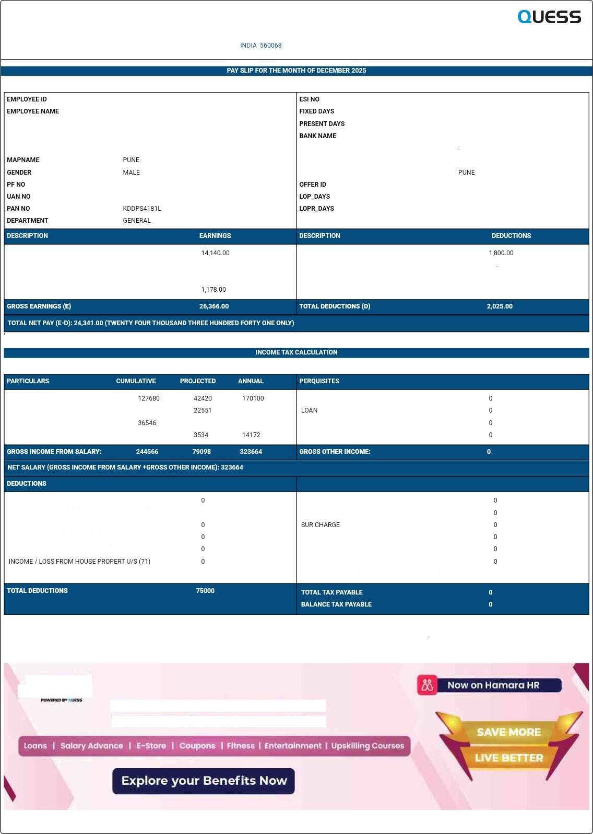


Quess introduces Homoro Benefits
Employee Benefits & Engagement Platform

LAN 29 2026 T0:OF PM

